SPSS Open Sample dataset for workshop.

Open data using Syntax

1. Sign in to Apps on Demand. [Written Instructions](https://docs.google.com/document/d/1Px8NWoKpV4onrthao60ZpX2NrbAec89j/edit?usp=sharing&ouid=117340435050962348521&rtpof=true&sd=true), [video instructions](https://www.youtube.com/watch?v=j-8-wAb6MZY)
2. Open SPSS
3. [Open Syntax file](https://libguides.library.kent.edu/SPSS/Syntax#:~:text=To%20open%20a%20new%20Syntax,syntax%20directly%20in%20this%20window.). File -> New -> Syntax
4. Copy and paste commands below into new Syntax window. Pasting into Apps on Demand session can be tricky. Use following link to understand how to copy and paste within Apps on Demand. [Copy and Paste in Apps on Demand](https://it.cornell.edu/appsondemand/copy-and-paste-non-chrome-browsers-apps-demand?utm_source=sidebar)

show dir.

cd "Samples\English".

GET

FILE='car_sales.sav'.

DATASET NAME DataSet1 WINDOW=FRONT.

1. Highlight commands. Click Green Play Icon to run commands and open dataset.

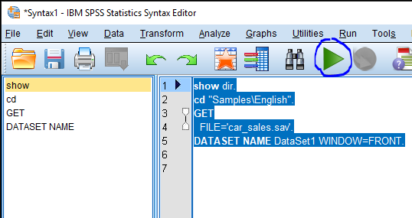

Download and Open Data

1. Sign in to Apps on Demand. [Written Instructions](https://docs.google.com/document/d/1Px8NWoKpV4onrthao60ZpX2NrbAec89j/edit?usp=sharing&ouid=117340435050962348521&rtpof=true&sd=true), [video instructions](https://www.youtube.com/watch?v=j-8-wAb6MZY)
2. Open Google Chrome from WITHIN Apps on Demand.

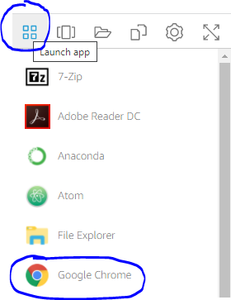

1. Use link below to access and download dataset. This will download to “Downloads” folder. Pasting into Apps on Demand session can be tricky. Use following link to understand how to copy and paste within Apps on Demand. [Copy and Paste in Apps on Demand](https://it.cornell.edu/appsondemand/copy-and-paste-non-chrome-browsers-apps-demand?utm_source=sidebar)

<https://drive.google.com/file/d/1a2C_tTpWkFAKkVRiHwV6oEBn-xQvBgd3/view?usp=sharing>

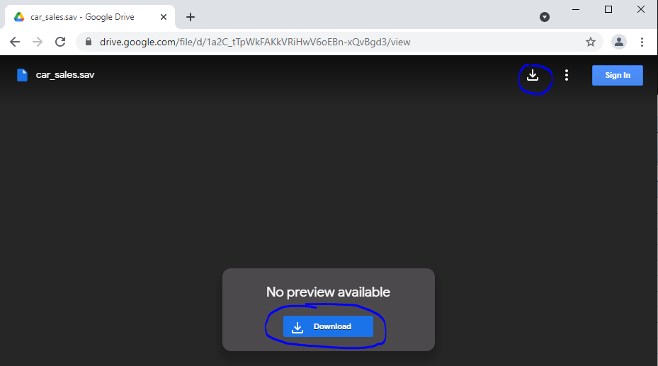

1. Open SPSS
2. [Open SPSS dataset](https://academicanswers.waldenu.edu/faq/157491) File -> Open -> Data -> Downloads folder -> select data and open

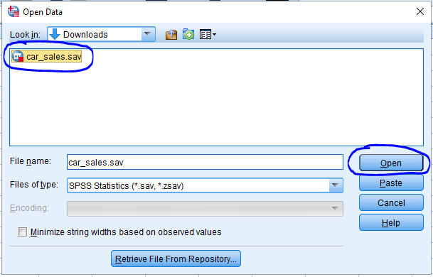

Download Syntax and Open Data

1. Sign in to Apps on Demand. [Written Instructions](https://docs.google.com/document/d/1Px8NWoKpV4onrthao60ZpX2NrbAec89j/edit?usp=sharing&ouid=117340435050962348521&rtpof=true&sd=true), [video instructions](https://www.youtube.com/watch?v=j-8-wAb6MZY)
2. Open Google Chrome from WITHIN Apps on Demand.



1. Use link below to access and download syntax. This will download to “Downloads” folder. Pasting into Apps on Demand session can be tricky. Use following link to understand how to copy and paste within Apps on Demand. [Copy and Paste in Apps on Demand](https://it.cornell.edu/appsondemand/copy-and-paste-non-chrome-browsers-apps-demand?utm_source=sidebar)

<https://drive.google.com/file/d/1uTo5MX4f6GyCEIlwZpIbDT-sRMiIB4gp/view?usp=sharing>

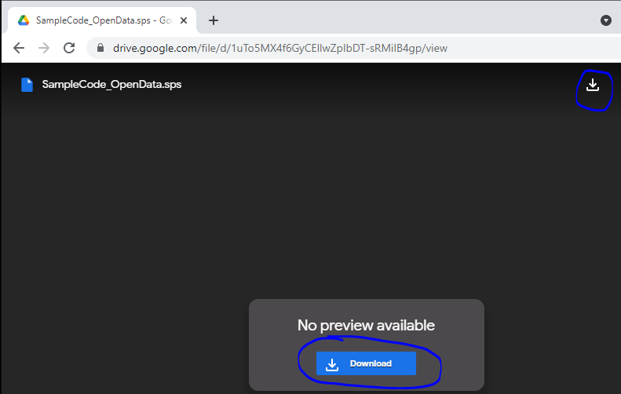

1. Open SPSS
2. Open SPSS Syntax. File -> Open -> Syntax -> Downloads Folder -> Select syntax file and open.

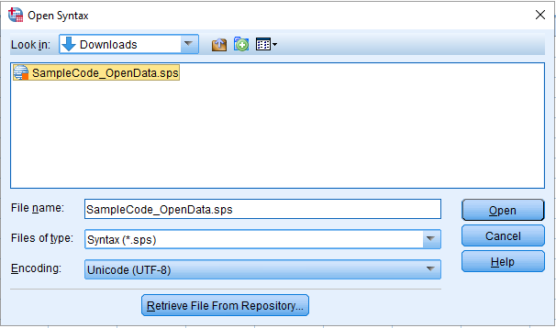

1. This will open Syntax file. Highlight commands. Click Green Play Icon to run commands and open dataset.

